The What’s

The Who’s

The Why’s

Of the Clown’s

The King’s Clown Troupe has been an

active ministry at Prince of Peace

for over 25 years. Throughout the years

more than 200 high school youth between

the ages of 14 and 18 have

belonged to the troupe.

They have led worship in over

1,000 congregations

throughout the United States and Ireland

The troupe continues to grow with God’s love.

Our teens give of themselves,

their time and talents to help

spread God’s word.

**j0086734**

The King’s

Clown Troupe

Mission

The King’s Clown Troupe welcomes

all people and spreads God’s love as

we witness, affirm and express our

faith through service of

mime and celebration.

The Troupe seeks to grow in love, reach

others near and far, support one another

and trust God in a unique and interesting way

that allows us to learn more about ourselves and cause changes in others.

We recognize that we are part of a

tradition at Prince of Peace,

whose legacy of love and laughter

is built upon our faith in

Jesus Christ.

j0086816

Come Worship

With the

Clown’s

*You are invited to see ,hear, and feel God’s word like you have never thought you could. You might laugh, you might cry, you are encouraged to sing along, and if the spirit moves you to dance, Let’s dance!*

*Since we don’t talk, we use our music and our actions to do the verbalization for us.*

The Clown Troupe’s worship services

are designed for all ages and denominations.

They combine contemporary music, dancing,

mime and drama into one

fantastic experience. They believe the

clown is a fool for Christ, but not foolish.

Clowns are childlike, but not childish.

They are servants who go among God’s

people to bring inspiration,

joy and fellowship.

Worship times vary depending on

the size of the congregation.

However, services average approximately

1 to 1 ½ hour in length.

The Clown Troupe will take care

of the entire service including

passing out of bulletins and offering.

Communion is typically included in the

service and the Pastor provides the words

of Institution. However, communion

can be excluded if preferred.

Contact

Information

The King’s Clown Troupe

works with 3 adult advisors

Rev. Amber Waugaman

Andy Lustofin

Jim Netzer

All inquires for availability

of the Clown Troupe

or questions in general

should be directed to Andy

Please contact her at

[mhuggles@nycap.rr.com](mailto:mhuggles@nycap.rr.com)

or 518 852-3098

BD05007_

Comments

From past

Congregations

“A truly wonderful presentation

by youth inspired by God”

“What a joyous expression

of worship”

“I have never participated in a more

joyful and spirit-filled service”

“The service was truly inspiring”

“We were moved, blessed, impressed

and inspired”

“Hearts were touched”

“What a wonderful way to

share the gospel”

j0086830

**The**

**King’s**

**Clown Troupe**

Prince of Peace

Lutheran Church

Clifton Park, NY

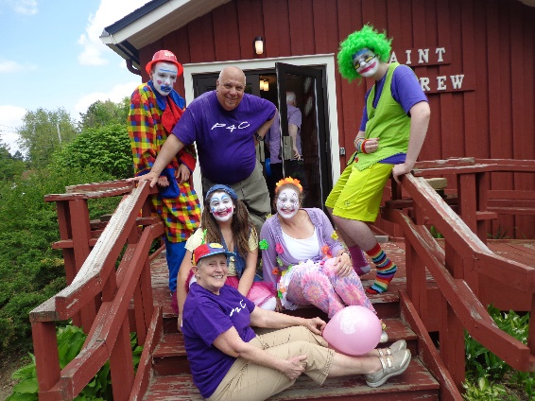

**Sharing God’s Love**

